Home Page



This screen shows the layout of the website as a prototype.

Donations Page

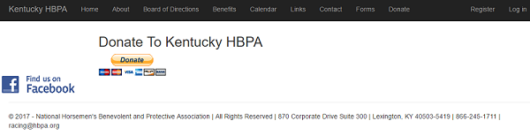

The donations screen prototype shows a button linking to a 3rd party site, such as Paypal, for handling online payments such as donations.

Registration Page

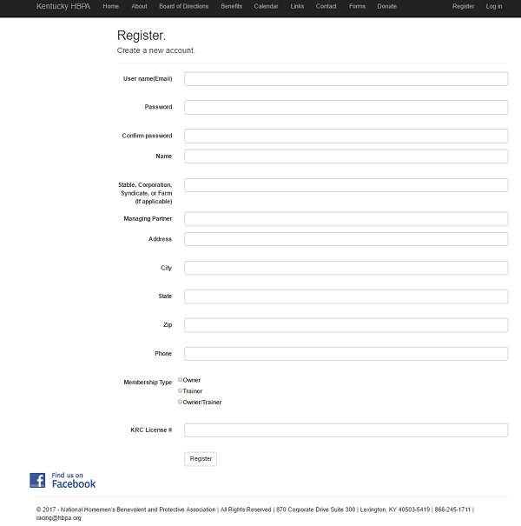

The registration page prototype shows the inputs for registering as a new member.

Mobile Home Page



This screen shows the layout of the web prototype for mobile users. Note that the menu buttons at the top as displayed on the desktop page have been moved to the drop down menu at the top right corner.

Mobile Menu

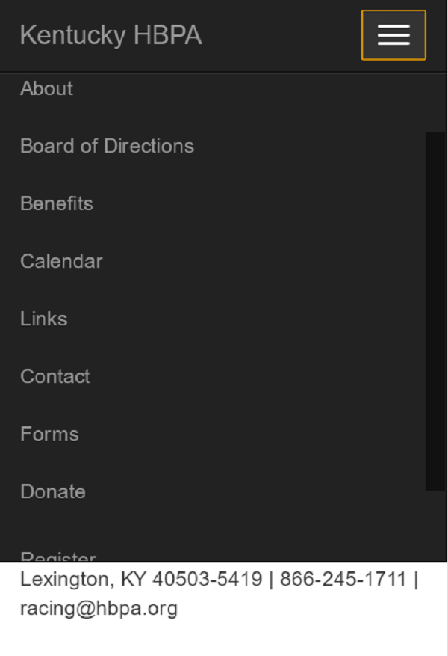

This screen shows the prototype for the mobile menu and its scrollable interface.

Mobile Registration Page

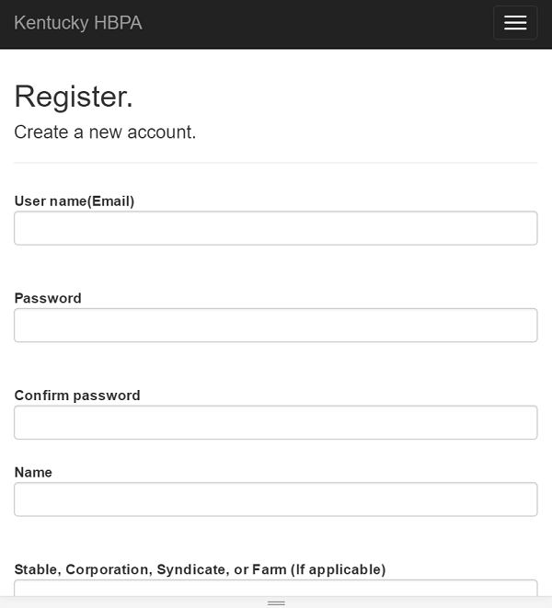

This screen shows the registration page as it might appear on a mobile device.